**cLab Assignment – Enterprise IAAA Part 1 (Authentication)**

**Guideline:**

* You are **ALLOWED** to reference the course materials and online content to complete the lab.
* It is your responsibility to **BACKUP** your virtual machine(s) to your external drive.

**Deliverables**

* Provide answers for questions outlined in the last page of this document. The answers will be in a form of screenshots that shows the command and associated output. Make sure the screenshots are visible and clear before uploading and submitting to Brightspace.

**Server Virtual Machine and O/S Requirements**

**Provision the following settings for a virtual machine using either VMware Workstation.**

* Create a new virtual machine that contains the following specifications
  + The guest operating system of the virtual machine should be **Windows Server 2019/2022**

Windows Server 2019 Standard (updated Mar 2023)

Product Key: DX9KC-NKB92-2YG88-JPXGR-GX2HQ

* + Assign **4GB RAM** to the virtual machine **BEFORE** installing the operating system.
  + Start your virtual machine and install the operating system.
  + Select **Windows Server 2019 (Desktop Experience)**
  + Continue the setup using the default options
  + Set your preference for the administrator password
  + Install VM tools to assist in moving content from the host computer to the virtual machine and vice versa.

**Active Directory Domain Requirements**

* + Configure a static IP of your choice.
  + Change the computer name to make it match your first name with”01” appended to it. For example, if your first name is Bruce then your computer name should be Bruce01
  + Install Active Directory Domain Services role
    - Promote the server to a domain controller.
* The new forest name: your first name with “.local” appended to it. For example, if your first name is Bruce then your forest name should be Bruce.local
* The NetBIOS domain name: Your first name (This will get filled automatically)
* Follow the setup Wizard and continue with the default options.
* At the end of the installation, the server will restart automatically.

**Active Directory Domain Administration**

* + Login to the server using the domain administrator account and open Active Directory Users and Computers and create the following objects (Refer to the diagram on the next page for guidance)
    - Create an OU under the root domain and the name of the OU should be your last name. For example, if your last name is Wayne then the OU name should be Wayne
    - Under your last name OU, create the following objects
      * OU: Finance
      * OU: Information Technology
    - Under the Finance sub OU, create the following objects
      * OU: Account Payable
      * OU: Account Receivable
    - Under Account Payable OU, create the following objects

|  |  |  |  |  |
| --- | --- | --- | --- | --- |
| Object Type | First name | Last name | Full name | User Logon name |
| User | Henry | Ford | Henry Ford | Henry.Ford |
| User | Enzo | Ferrari | Enzo Ferrari | Enzo.Ferrari |

* + - Under Account Receivable OU, create the following objects

|  |  |  |  |  |
| --- | --- | --- | --- | --- |
| Object Type | First name | Last name | Full name | User Logon name |
| User | Ferdinand | Porsche | Ferdinand Porsche | Ferdinand.Porsche |
| User | Louis | Chevrolet | Louis Chevrolet | Louis.Chevrolet |
| User | Karl | Probst | Karl Probst | Karl.Probst |

* + - Under the Information technology OU, create the following object
      * User: First Name+Last Name. For example, if your first name is Bruce and your last name is Wayne then the username should be Bruce Wayne (User logon name: Firstname.lastname).

**Client virtual machine and O/S Requirements**

* Create a new virtual machine that contains the following specifications
  + The guest operating system of the virtual machine should be **Windows 10**
  + Assign **4GB RAM** to the virtual machine then install the operating system.
  + Continue the setup using the default options
  + Set your preference for the local administrator password
  + Install VM tools to assist in moving content from the host computer to the virtual machine and vice versa.

**Client Configuration Requirements**

* + Configure a static IP of your choice.
  + Set the computer name to Client01.
  + Join the client to the domain
  + Login to the client using the Henry Ford’s account then Louis Chevrolet’s account

🡪 base from convo with tito Joshua Canilang, you need to make a client account , tapos dun mo sya ilologin as Henry.Ford. So probably related to page 7 of Windows IAAA Concepts, Windows Local User Accounts

**Un: Arr\Henry.Ford**

OLD PW: BlueSky!2025Road

New pw of HENRY: **qwerty01A!HENR**

**Domain Password Policy -🡪 refer to psge 12 of Windows IAAA concepts**

* + Set the default domain policy to enable Password complexity, set the password history to 12, maximum password age to 60 days, minimum password age 10 days, and password length to 14 characters

**Your AD structure should look like this:**

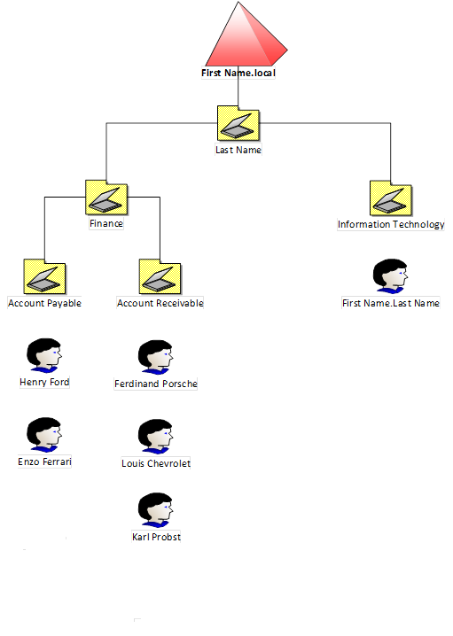

**Questions**

**Note: Provide screenshots for below requirements as evidence of your configuration. The screenshots must show your command and the output of the command. Editing/cropping screenshots will not be accepted**

1. Login to your AD domain controller and type **dsquery user -name \*** in command prompt. This command will list all users created in the domain. Take a screenshot and save it as jpeg file.

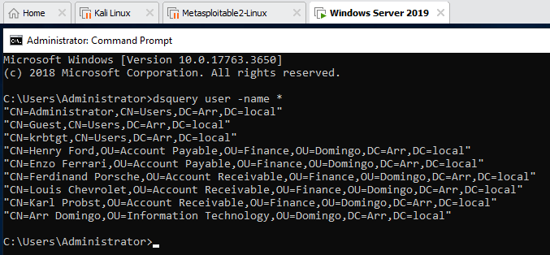

1. On your AD domain controller, type **dsquery ou -name \*** in command prompt. This command will list all OU created in the domain. Take a screenshot and save it as jpeg file.

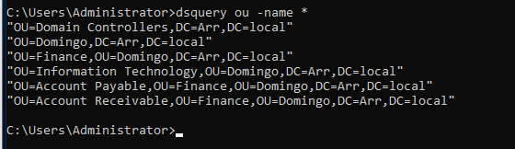

1. On your AD domain controller, type **dsquery computer -name \*** in command prompt. This command will list all the computers that are joined to the domain. Take a screenshot and save it as jpeg file.

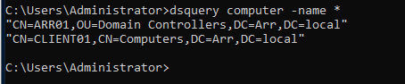

1. Login to your client computer using a normal account and type **gpresult /H Report.html** in the command prompt as admin (Run as Admin). This command will display the list of applied policies. Make sure the password policy is shown under computer details > Settings > Policies > Windows Settings > Security Settings > Account Policies/Password Policy. Report.html is available under C:\Users\administrator

Enable Shared Folders to Access Files Between Your Host and Virtual Machines in VMware Workstation

https://www.youtube.com/watch?v=6aeTYkGpOkI

**BEFORE PASSWORD NOT SET**

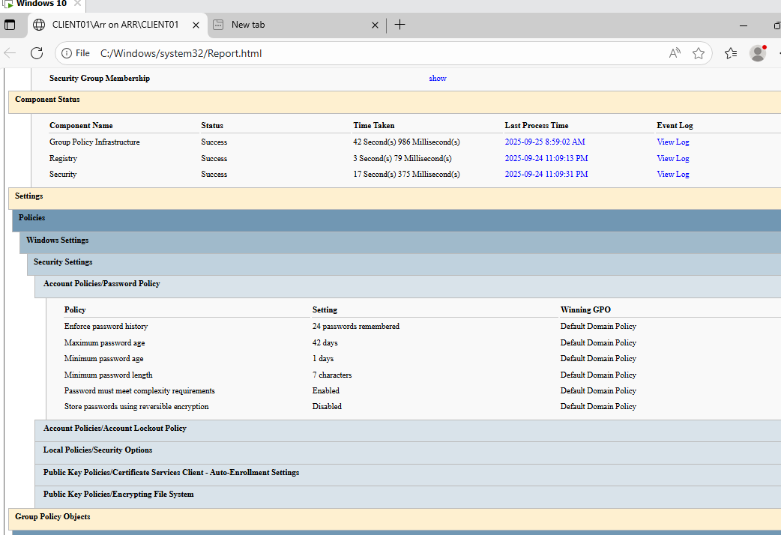

**AFTER UPDATING PASSWORD POLICY**

1. On your AD domain controller, type **systeminfo > C:\AD.txt** in the command prompt. This command will display the domain controller environment.

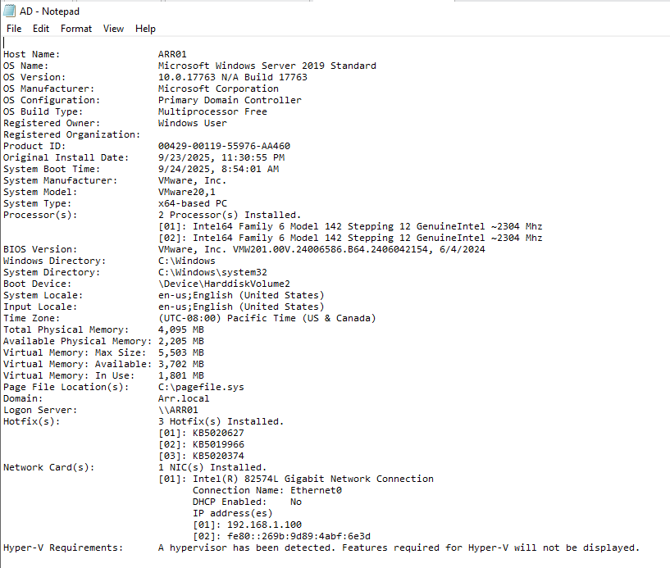

**Marking Guide**

Each screenshot should show the command you typed and the out of the command. The grades are divided equally among all requirements. Each answer is worth 2% out of 10%. No partial marks on individual requirement.

|  |  |  |  |
| --- | --- | --- | --- |
| Deliverables | (Yes / No) | Feedback | Marks (2% Each) |
| **dsquery user -name \*** |  |  |  |
| **dsquery ou -name \*** |  |  |  |
| **dsquery computer -name \*** |  |  |  |
| **Report.html** |  |  |  |
| **AD.txt** |  |  |  |

**Submission**

You are required to submit the following in a single zip folder

1. A single screenshot for requirement 1, 2, and 3. (Total of 3 screenshots)
2. Report.html.
3. AD.txt
4. All above submissions must be saved in a folder then zipped and uploaded to Lab 1 – Part 1 (Authentication) on Brightspace.